# Simulations of STIX Flare Detection using RHESSI Data

Ewan Dickson Version 1.0   
Univ. Graz (Austria) 23-July-2018

## Introduction

### Flare Detection Module

The purpose of the flare detection algorithm is the real-time identification of time intervals corresponding to flaring activity using the change in the estimated total count rates in a quick-look time interval in two energy bands corresponding to thermal and non-thermal emission.

### Previous Flare Detection Testing

Most of the previous testing of the flare detection module has been performed by specifying relatively short scenarios with time profiles based on simple functional forms, such a linear increases or Gaussian pulses. Later slightly more complex and realistic profiles with a Gaussian rise and an exponential drop-off were also included to more closely mimic the standard X-ray flare lightcurves. As theses profiles were parametrically specified the exact counts in each time bin and energy range can be calculated and therefore the exact behavior of the flare detection algorithm with any set of parameters can be estimated. To test our flare detection routine was working as expected these estimates were compared with the results of running the scenarios through the full fight software simulator.

In the integration test scenario, stx_scenario_flare_detection__test (Figure 1), we have four successive sources, each with a linearly increasing time profile. The durations of the sources are 60, 32, 60 and 28 seconds. Each source is designed to test a specific baseline-energy configuration. For each test the flare_flag property is retrieved from the flight software simulator object and the value of the flare flags, or the time bin where a relevant transition occurs, for example the flare flag switching on, are compared with the expected values. Tests are performed firstly on the full flare flag over the total time range of 600 seconds, then on the individual flare magnitude indices for the

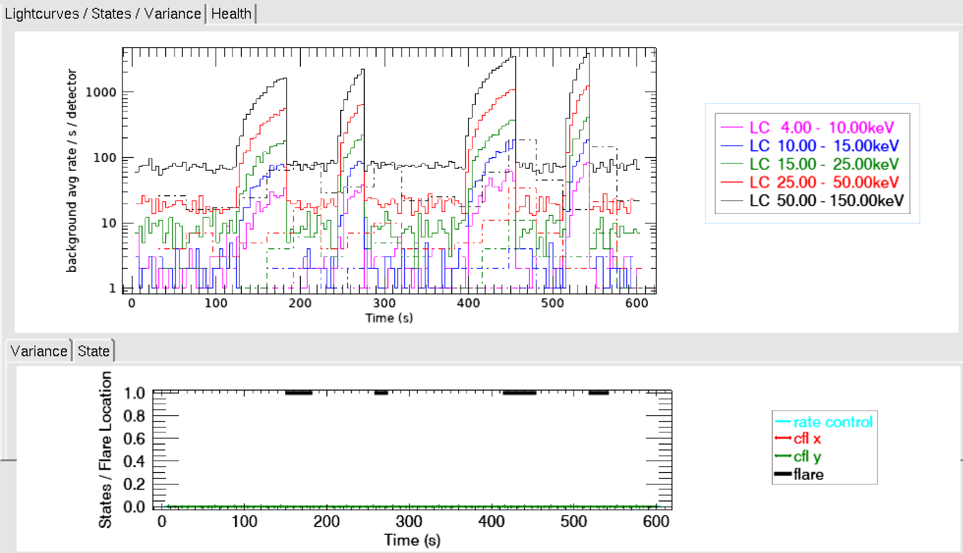

Figure 1 : The standard flare detection scenario integration test. Top: Lightcurve in standard quicklook bands. Bottom: Flare Flag output of flare detection algorithm for these counts

This scenario stx_scenario_flare_detection_short (Figure 2) consists of 6 flare events over both energy bands and baseline durations. It is designed to be shorter than the more comprehensive tests so it can also be applied to the testing of the real flight software while still testing all aspects of the flare detection algorithm. Each event starts with a half short baseline duration of only background so at least one condition is reset to 0 between events. The thermal and non-thermal conditions are tested separately with the counts in the energy band not being tested set to a constant value around the expected median.

The events have a range of intensities and are also made up of a combination of short Gaussian pulses and longer events with Exponential decay tails. The decay constant of the exponential functions are set so that they reach 1 count per time bin at the end of the event.

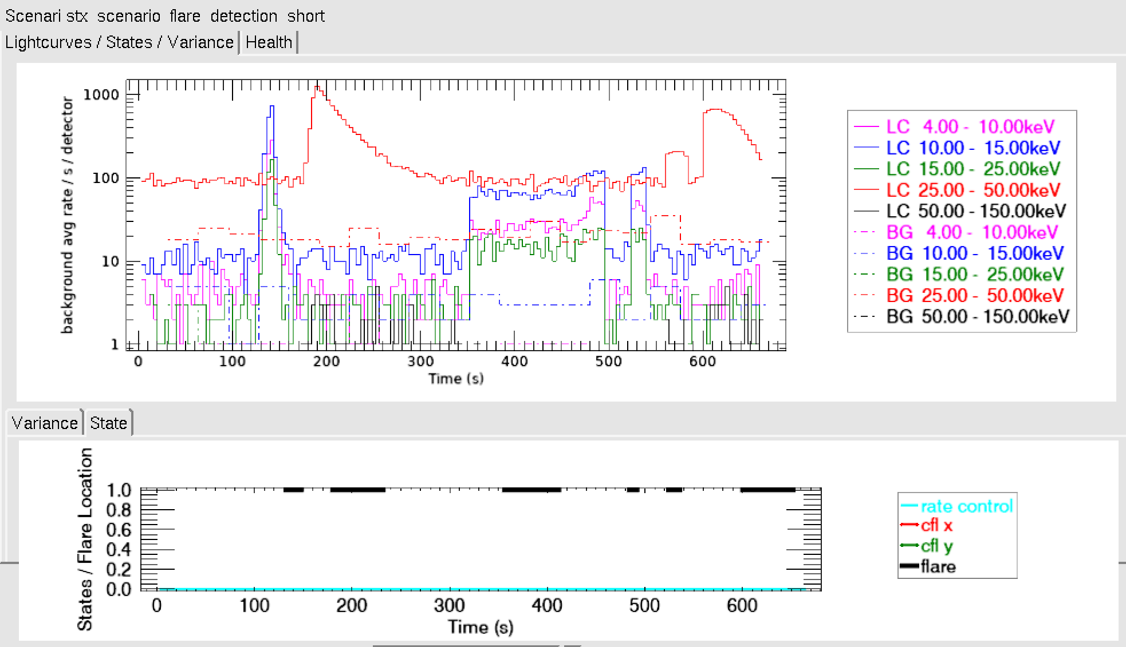

Figure 2: The short flare detection scenario integration test. Top: Lightcurve in standard quicklook bands. Bottom: Flare Flag output of flare detection algorithm for these counts

### General setup

The long baseline was set to 1200 s and the short to 60 s. All other parameters match the defaults specified in the config file \stix\dbase\conf\stx_flight_software_simulator_default.xml (Table 1)

The energy ranges for the flare detection algorithm are defined in STIX-TN-0108-FHNW_I5R2_FSW_Flare_Detection as channels 4 – 11 for the thermal and 16 – 21 for the nonthermal, this corresponds to bands 8 – 16 keV and 25 – 50 keV respectively (using the energy binning specified in \stix\dbase\detector\EnergyBinning20150615.csv). The nominal background was estimated using the model background described in STIX-TN-0027-ETH_I1R0_Background_Rates and used as the model in our simulations in stx_bkg_continuum_mdl for the expected value in each energy band. Therefore, the baseline values for the background are set to 0.36 counts per 4 seconds per detector over the thermal band and 2.4 counts/4 seconds/detector over the non-thermal band.

Table 1: Flight software simulator parameters used for the flare detection algorithm

|  |  |  |
| --- | --- | --- |
| **Parameter** | **Value** | **Description** |
| update_frequency | 4 | Update frequency of this module in second |
| nbl | [1200.,60.] | Seconds for the median window of 2 time series |
| thermal_cfmin | [36,36] | Count threshold to turn on a flare for both time series in the thermal band. |
| nonthermal_cfmin | [50,50] | Count threshold to turn on a flare for both time series in the nonthermal band |
| thermal_kdk | [0.2,0.2] | Relative kdk factor for both time series for the thermal band |
| nonthermal_kdk | [0.2,0.2] | Relative kdk factor for both time series for the nonthermal band |
| thermal_krel_rise | [1.5,1.5] | Relative krel factor for both time series for the thermal band |
| nonthermal_krel_rise | [1.,1.] | relative krel factor for both time series for the nonthermal band |
| thermal_krel_decay | [0.5,0.5] | Relative krel factor for both time series for the thermal band |
| nonthermal_krel_decay | [0.5,0.5] | relative krel factor for both time series for the nonthermal band. |
| kb | 1. | Background scaling factor for all energies and times. |
| flare_intensity_lut_file | stx_fsw_flare_intensity.csv | This is a file path to the flare intensity lookup table |

## Further Data Simulations

Some more simulations with the ideal parameterized data were performed to look at how varying the different parameters affects the timing of the flare detection. For these tests the flare lightcurve profile was based on a Gaussian convolved with an exponential decrease in the thermal band and a scaled Gaussian in the nonthermal band as this form is used to describe the elementary flare profile in several studies and has some physical justification based on considerations of energy release.

Thus the functional form used for the thermal counts was

$$f\left(x\right)= \frac{1}{2}\sqrt{π} a c \text{exp}\left[d \left(b-t\right)+\frac{c^{2}d^{2}}{4}\right]\left[\text{erf}\left(z\right)- \text{erf}\left(z- \frac{t}{c}\right)\right]$$

where

$$z= \frac{2b+ c^{2}d}{2c}$$

Flare profiles with fluxes between 25 and 30000 photons/s/cm2 , rise times between 5 and 30 seconds, thermal to non-thermal ratios between 0.01 and 0.005 and exponential decay timescales between 1.4 and 100 seconds were generated. An example is shown in Figure 3.

One of the things we want to test is the effect of variations in the background. The nominal background described in the previous section was used as the baseline with a sinusoidal component with a random phase and a random amplitude between 0 and 1 counts/4 seconds/detector.

The counts for this test are generated in the procedure stx_flare_detection_variable_background_test_counts.pro. The counts for these tests can be written to scenario files so they can be processed by the full detector simulator software and the flight software simulator and the output passed to synthetic STIX telemetry. stx_write_flare_detection_scenario.pro

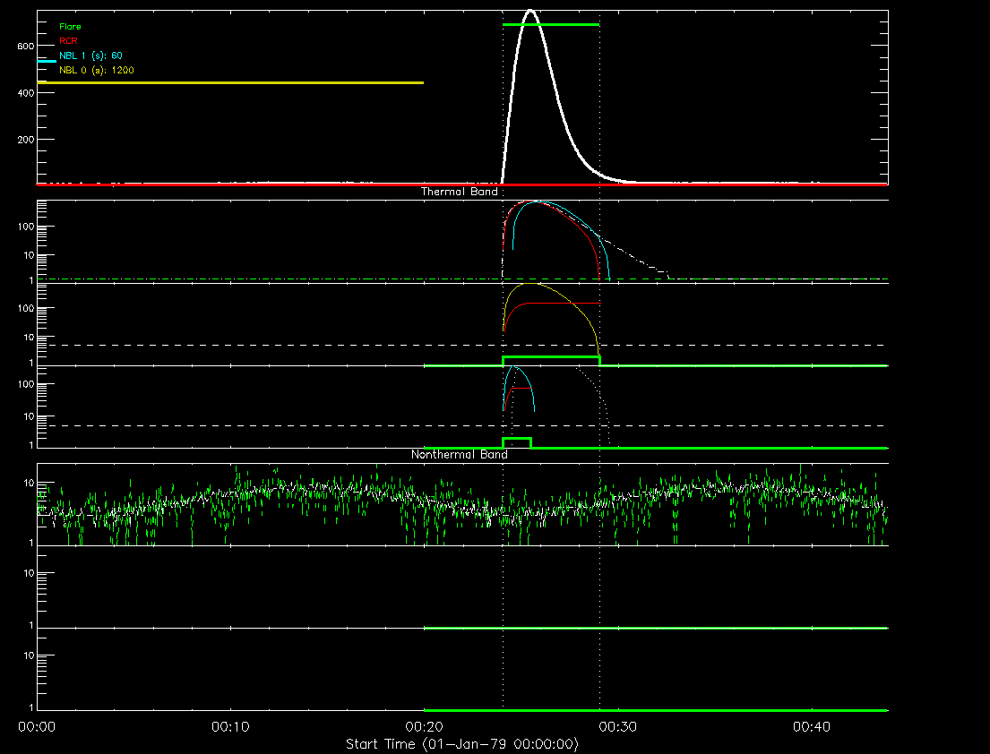

Figure 3: Example elementary flare profile with, a = 75 b = 10, c= 20 d =0.07 a_nonthermal =0.75, phase = 2.54, amplitude = 0.4

## Using RHESSI Data to Estimate STIX Counts

While the ideal flare profiles can be used to determine how the flare detection algorithm will perform in a wide range of scenarios the real lightcurves measured by STIX will be more complex with lightcurves likely to be very different from the standard elementary flare profile. RHESSI lightcurve data in similar energy bands provides a more realistic estimate of what the STIX flare detection input will look like and a more robust test of the algorithm.

The routine hsi_extrct_flx can be used to process the RHESSI observing summary data and get an estimate of to get the photon spectra for every 4 second time bin. These photons are then passed through the STIX response to estimate the counts in the two flare detection energy bands as a function of time.

One of the issues that occurred with this method was that RHESSI night as this would often produce false positives for the flare detection even when those intervals removed as there could be a jump in the number of counts between when RHESSI entered and exited night. Replacing the night time intervals with the median of the counts in a short period before and after seems to remove most of these false positives.

One thing that was noticed was that the higher energy counts look very different between RHESSI and STIX. When the derived photon fluxes in the non-thermal energy band are examined they can look quite different from the RHESSI count rates. As there is no background subtraction this could affect this as hsi_extrct_flux makes an estimate of the photon flux using the classic flare spectral profile of a thermal distribution plus a single power law but the high background counts at higher energies are likely to distort this if they are not accounted for. As the aim of this is to quickly estimate the lightcurve profile that STIX might see background is not accounted for here.

Another issue with using the hsi_extrct_flux photon estimates for all intervals is that RHESSI has a much higher background rate than STIX. And RHESSI background is a lot more variable in time than is expected for the STIX this can lead to false positives due to increased in the background rates that would not happen to STIX.

The STIX flare detection algorithm was also run purely on the RHESSI quicklook lightcurves on the closest bands (6 -12 and 25 – 50 keV) to see how well it would do. When the false postives due to RHESSI exiting night are ignored the STIX flare det4ection compares reasonably with the more sophisticated RHESSI flare detection.

Plots for full days to show an overview of how it compares when activity is moderate, intermediate and high are shown in Figure 4 - Figure 7.

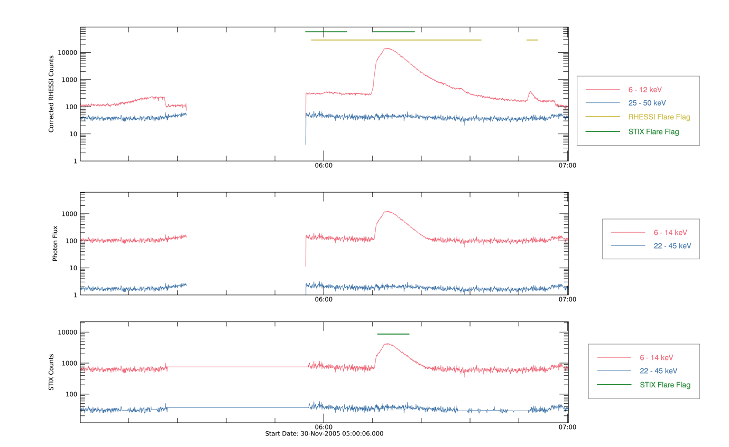

Figure 4: Lightcurve for a standard looking flare profile from 30-Nov-2005 05:00 to 07:00. Top: Corrected RHESSI Counts in the standard energy bands 6-12 (red) and 25-50 keV (blue). The RHESSI flare flag (yellow) and the output of the STIX flare detection algorithm applied to these counts are shown. Middle: Photon Light curve estimated applying hsi_extrct_flx to the observing summary data for this time period. Bottom: Estimate of STIX counts from hsi_extrct_flx photons in the flare detection thermal (red) and non-thermal (blue) energy bands. The STIX flare flag i.e. the output of the STIX flare detection algorithm applied to these counts is shown (green)

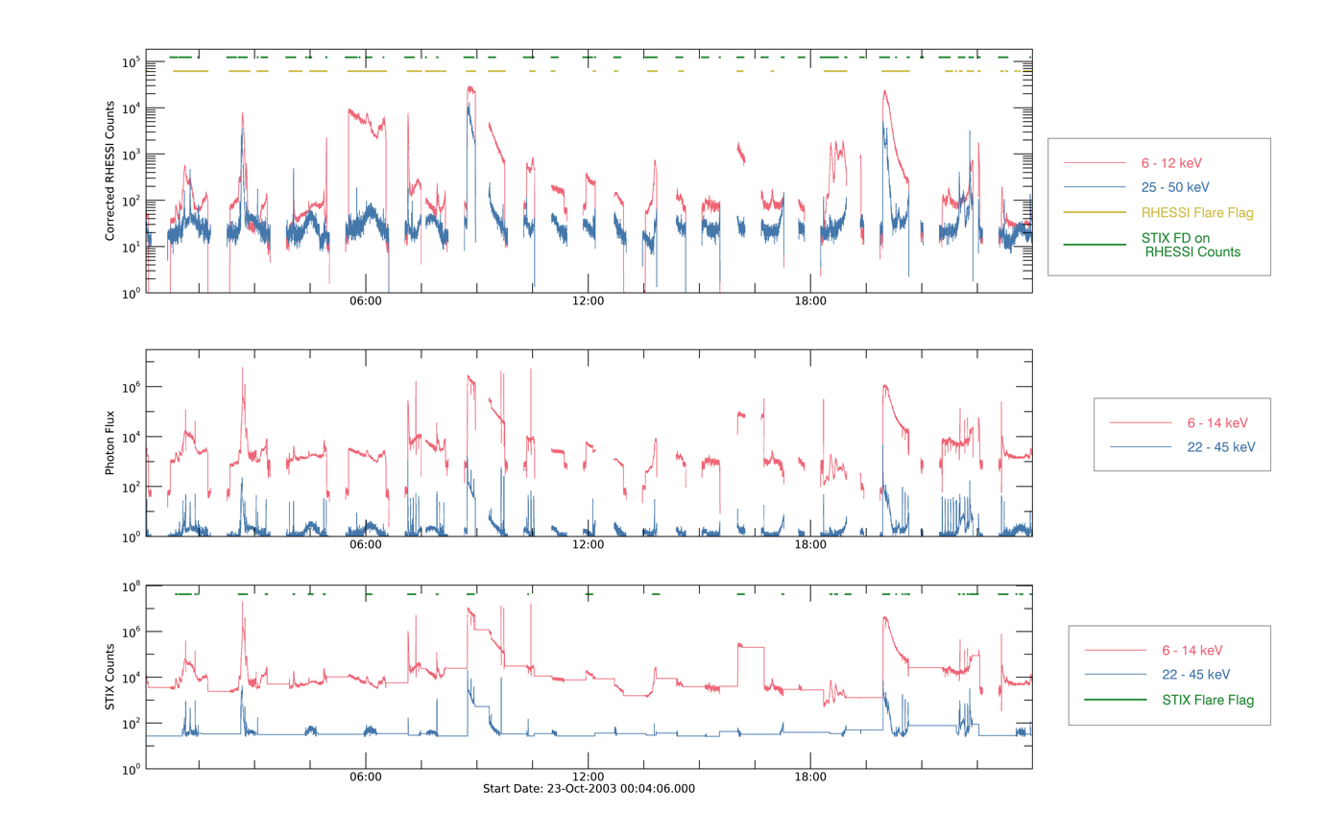

Figure 5 : As Figure 4 for the time range 23-Oct-2003 00:04 to 23:59. This day was chosen to test periods of high activity.

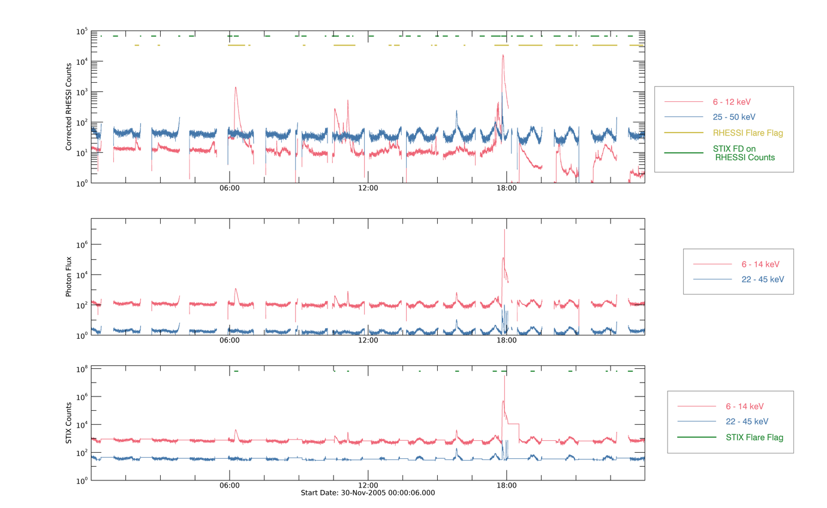

Figure 6: As Figure 4 for the time range 30-Nov-2005 00:00 to 23:59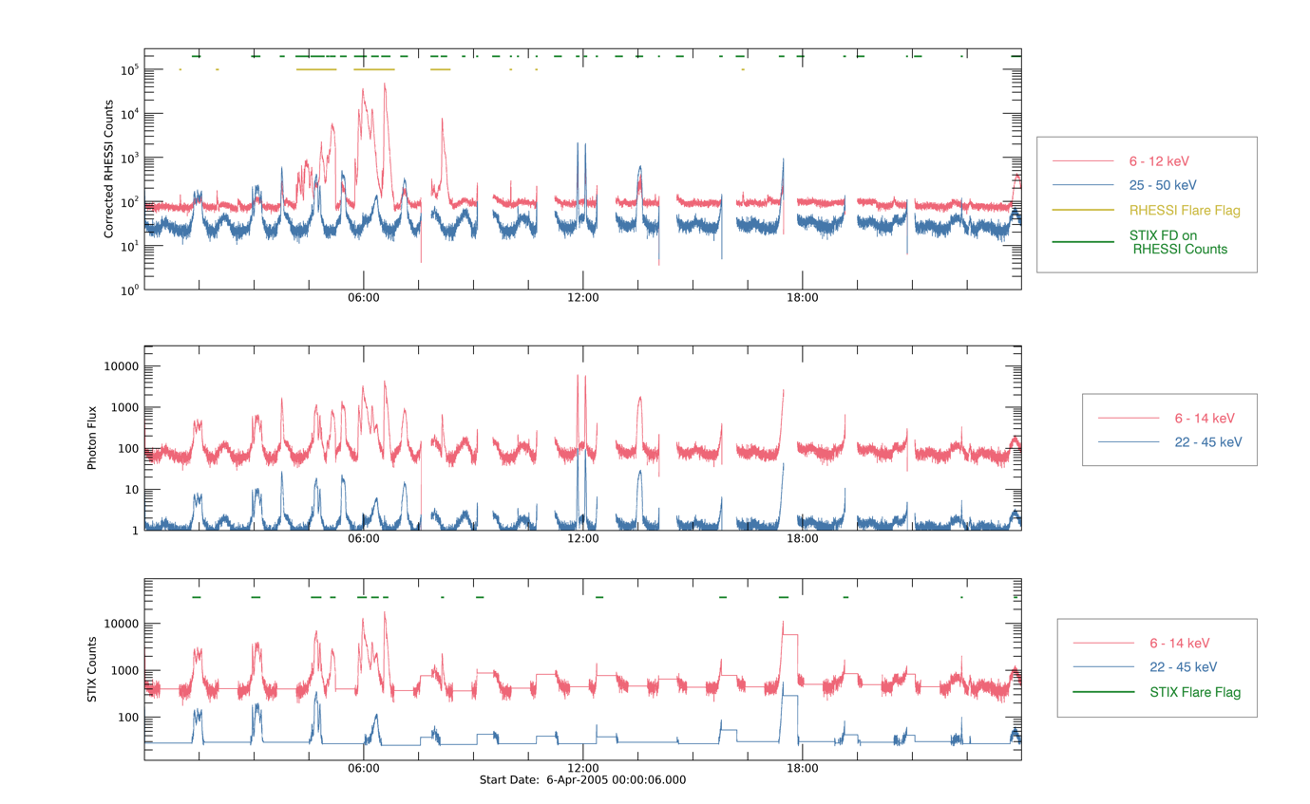

Figure 7 : As Figure 4 for the time range 6-Apr-2005 00:00 to 23:59. This day was chosen to test periods of high activity.

## Using RHESSI Lightcurve Data directly

As the range of flare properties is very large compared to the difference in instrument responses between RHESSI and STIX, scaled RHESSI lightcurves can be used directly as an estimate of the expected input counts for the flare detection algorithm. As RHESSI background is much higher than that observed by STIX some background subtraction has to be performed to get a more accurate estimate of what STIX will see. The lightcurves are extracted from the quicklook lightcurve in the 5 standard channels from the observing summary structure created by hsi_extrct_flx as in the previous section but these are then scaled to different intensities in the two energy bands. This potentially provides a more realistic estimate of what the STIX lightcurves will look like.

This is performed by the routine stx_flare_detection_rhessi_test.pro which can be found in the folder stix/idl/sim/fsw_testing

RHESSI background was removed by subtracting a constant value from the counts in the two quicklook bands 6-12 and 25 -50 keV. The estimates were made only by examining the corrected RHESSI lightcurves over the full range and selecting a single value for each band which would remove all non-flare counts.

STIX will observe and detect flares with a wide range of peak fluxes. To simulate this, we scale the RHESSI counts such that the maximum value in the thermal band in the input lightcurve in the thermal band is equal to the thermal scaling factor. Values of 600000, 60000, 6000 and 600 were used in our testing for the peak thermal fluxes. These are very roughly equivalent to the X1, M1, C1 and B1 GOES classes.

Non-thermal scaling is taken as a fraction of the peak thermal counts. A standard factor of 0.03 is used based on the average over a range of likely flare profiles with temperatures from 1.2 to 2 keV, non-thermal fluxes at 50 keV between 0.06 and 16 photons/s/kev/cm2 and non-thermal spectral indexes between 2 and 5. Alternative spectral ratios based on this distribution of 0.3 and 0.003 were also applied to see the effect of different spectra on the outcome of the flare detection.

We randomly generate background counts for 31 detectors, the 30 imaging detectors which are averaged to determine the input for the flare detection routine plus the background detectors for all timebins. Our background estimate is drawn from a Poisson distribution with expectation dependent on the energy channel currently being tested is used i.e. the nominal 0.36 and 2.4 counts/4 seconds/detector over the thermal band and non-thermal bands respectively.

As the true STIX background is unknown a multiplying factor is applied to this background expectation with the same value applied to both energy bands. In our testing values of 1, 2, 4, 8 and 16 were applied.

The background estimate for the current event is taken as the remaining detector count in values in the thermal_bkg_counts and nonthermal_bkg_counts arrays for all time bins. The total counts in each time bin are therefore the scaled RHESSI counts plus this estimate of STIX background.

To test background time variation a sinusoidally varying background was also added to the background of these lightcurves with random values generated for 31 detectors.

The flare detection routine is then run on this lightcurve, with the estimate from the background detector also provided. The specified config parameters as described in Table 1 are also used here.

A demonstration script stx_flare_detection_rhessi_test_demo.pro is also included in the folder stix/idl/sim/fsw_testing. This procedure runs the stx_flare_detection_rhessi_test for flares with a range of different fluxes (from 600 to 6e5), spectra (non-thermal ratios of 0.3, 0.03 and 0.003) and background estimates (factors of 1, 2, 4, 8 and 16). The RHESSI lightcurve from several days as the basis for the estimates of flaring activity in the thermal and non-thermal energy bands are used to test a range of flaring conditions. In this demonstration the dates 23-Oct-2003, 30-Nov-2005, 6-Jul-2003, 8-Jul-2003, 6-Apr-2005, 12-Oct-2005 and 12-Mar-2005 are used.

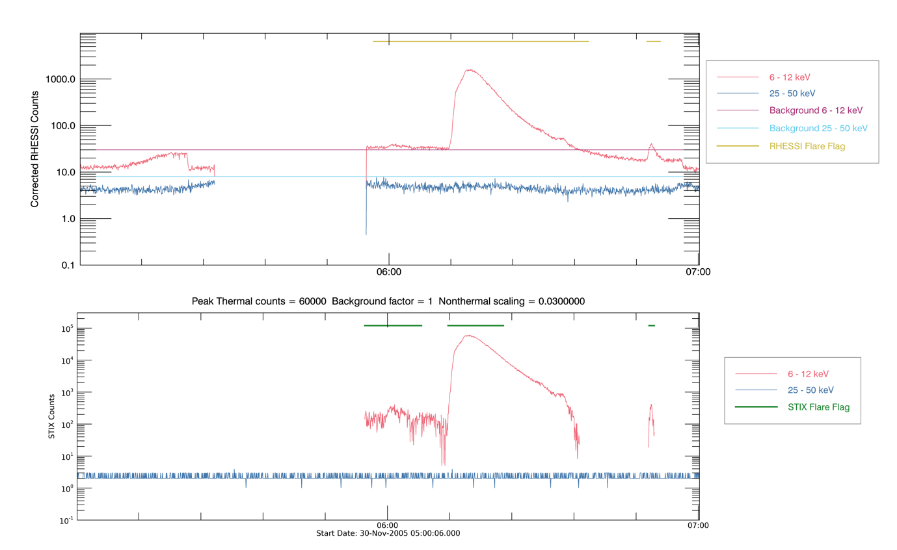

Figure 8 : Lightcurve for a standard looking flare profile from 30-Nov-2005 05:00 to 07:00. Top: Corrected RHESSI Counts in the standard energy bands 6-12 (red) and 25-50 keV (blue) along with the constant background estimates for each energy band (purple and light blue respectively. The RHESSI flare flag (yellow) for these counts is shown. Bottom: Estimate of STIX counts from hsi_extrct_flx photons in the flare detection thermal (red) and non-thermal (blue) energy bands. The STIX flare flag for these counts is shown (green)

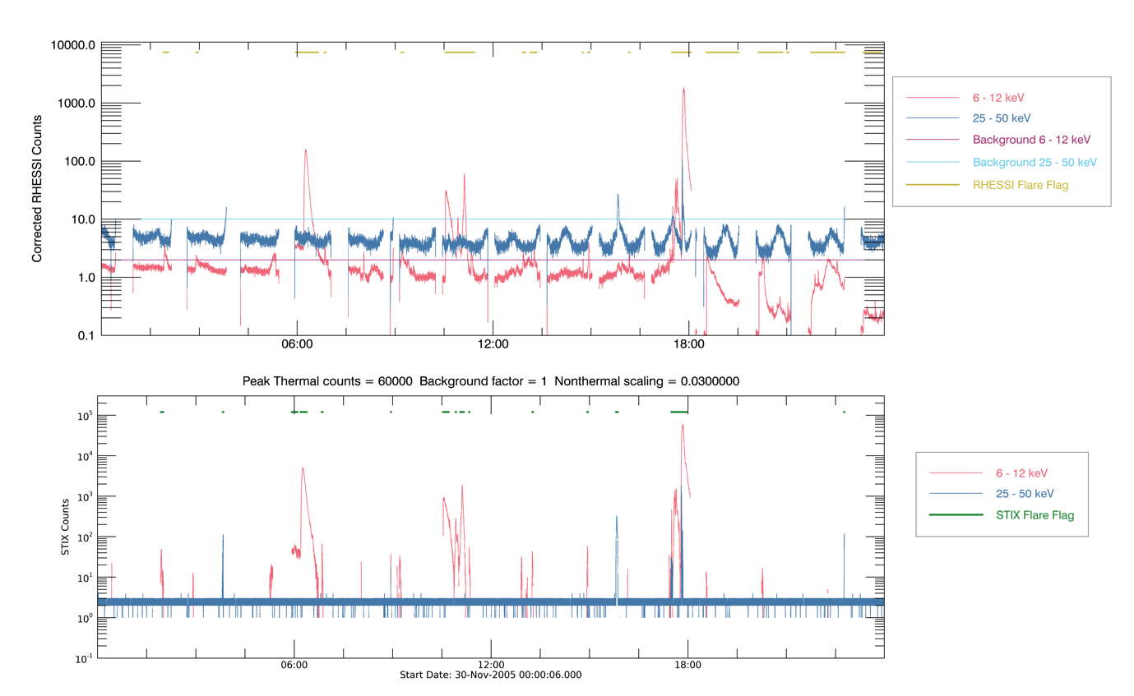

Figure 9 : As Figure 8 for the time period 30-Nov-2005 00:00 to 23:59

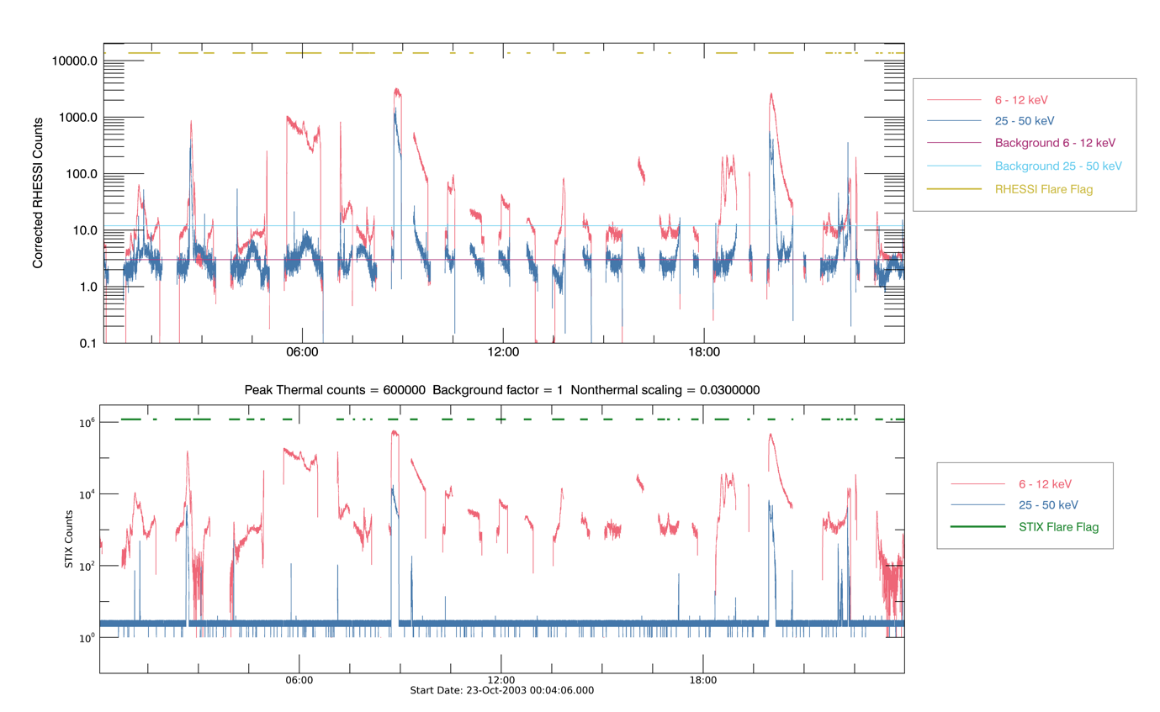

Figure 10 : As Figure 8 for the time period 23-Oct-2003 00:04 to 23:59

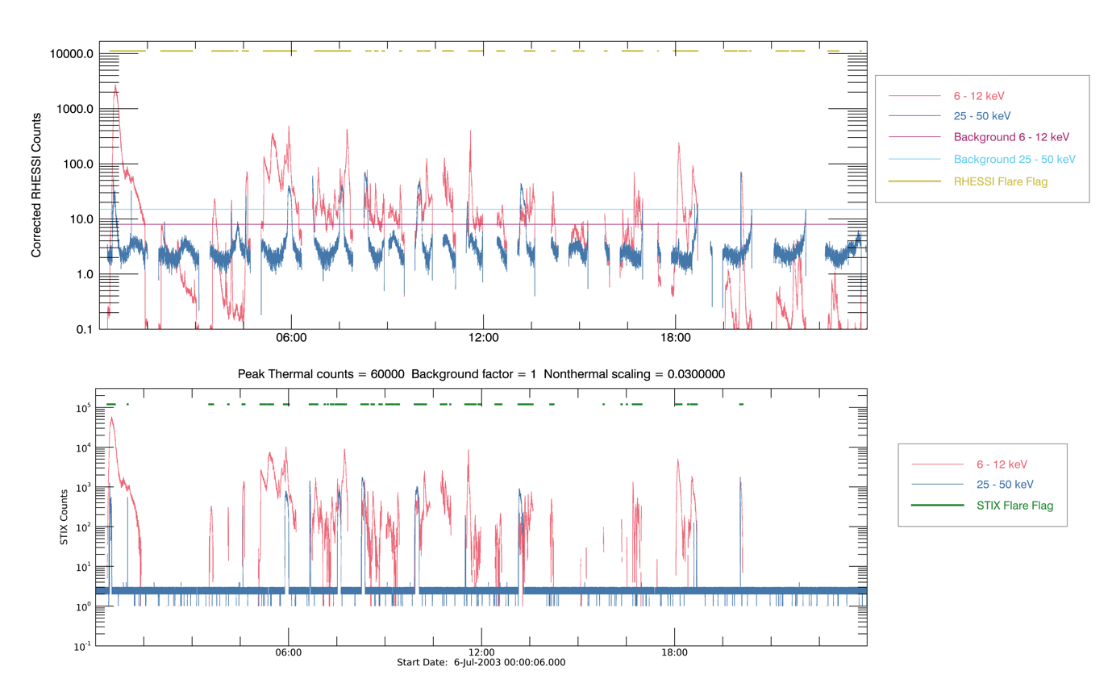

Figure 11 : As Figure 8 for the time period 6-Jul-2003 00:00 to 23:59

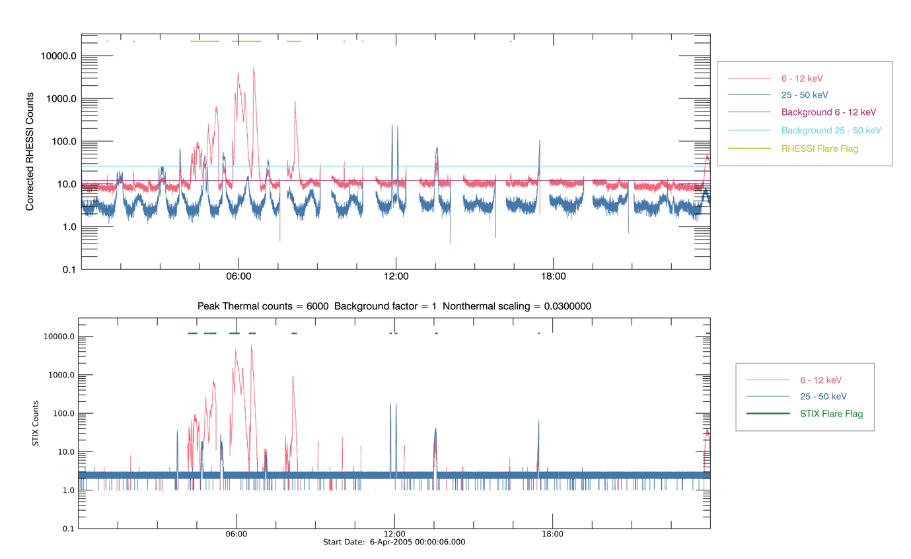

Figure 12 : As Figure 8 for the time period 6-Apr-2005 00:00 to 23:59

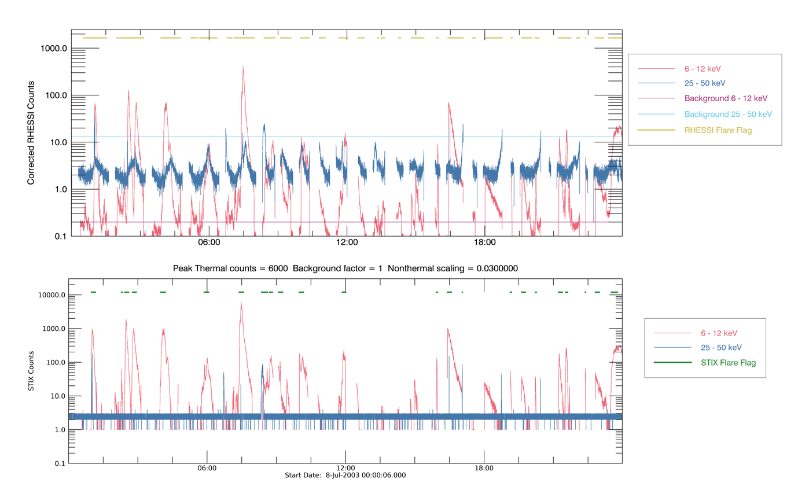Figure 13 : As Figure 8 for the time period 8-Jul-2003 00:00 to 23:59

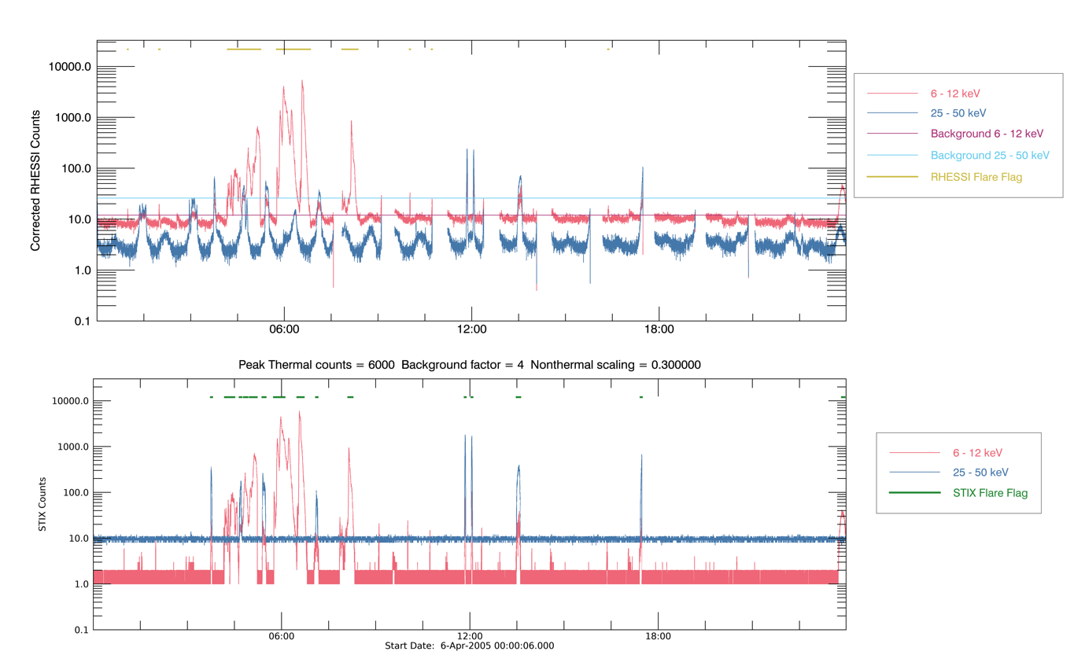

Figure 14 : As Figure 8 for the time period 6-Apr-2005 00:00 to 23:59

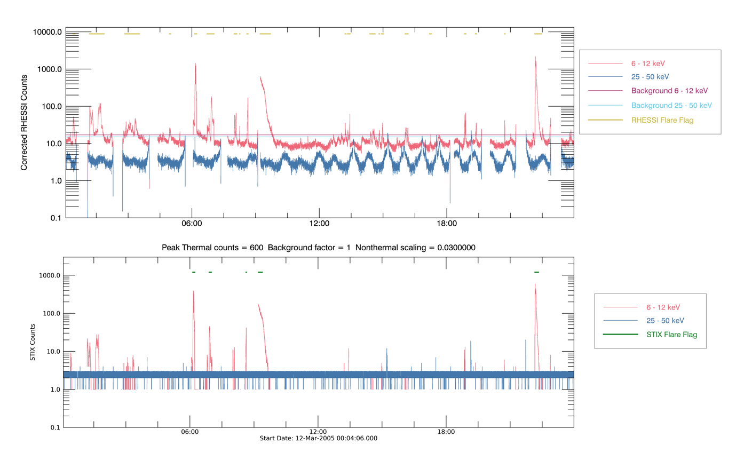

Figure 15 : As Figure 8 for the time period 23-Oct-2003 00:04 to 23:59

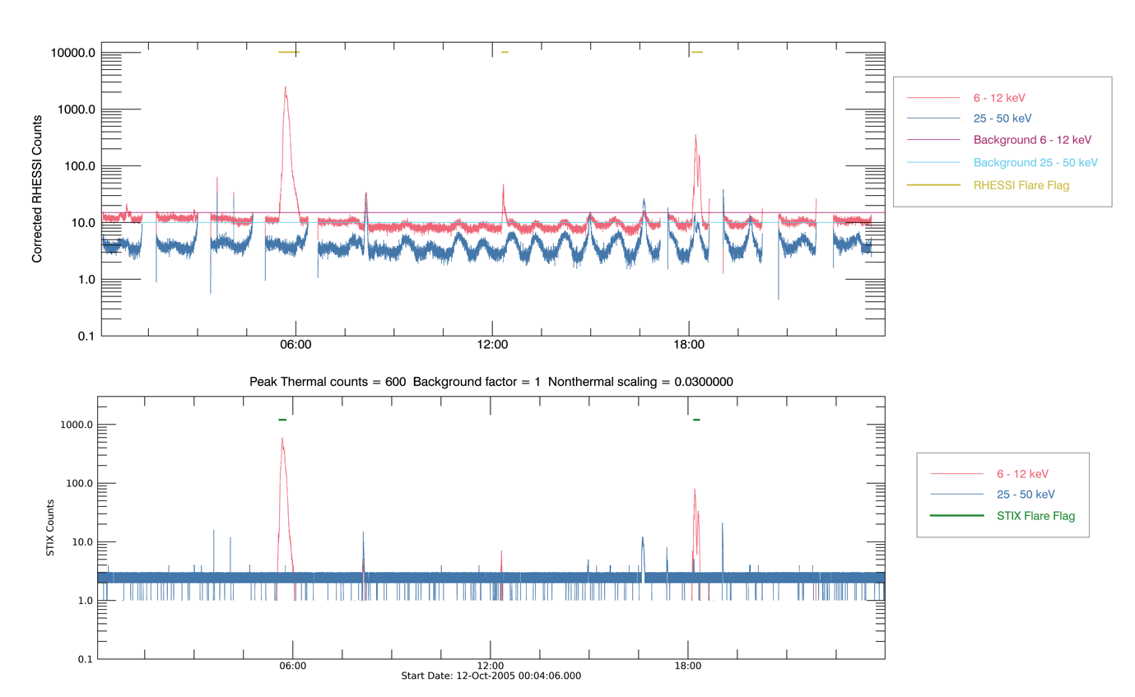

Figure 16 : As Figure 8 for the time period 23-Oct-2003 00:04 to 23:59

### Change in non-thermal contribution

As flare spectra are very variable the contrition of the non-thermal component compared with the thermal component can be very different. Tests were run with the non-thermal contribution either enhanced or reduced by a factor of 10. For the lightcurves used the triggering of the flare flag mostly seemed to be dominated by the thermal profile.

### 

Figure 17 : As Figure 10 with the non-thermal contribution enhanced by a factor of 10, i.e. a thermal/non-thermal ratio of 0.3.

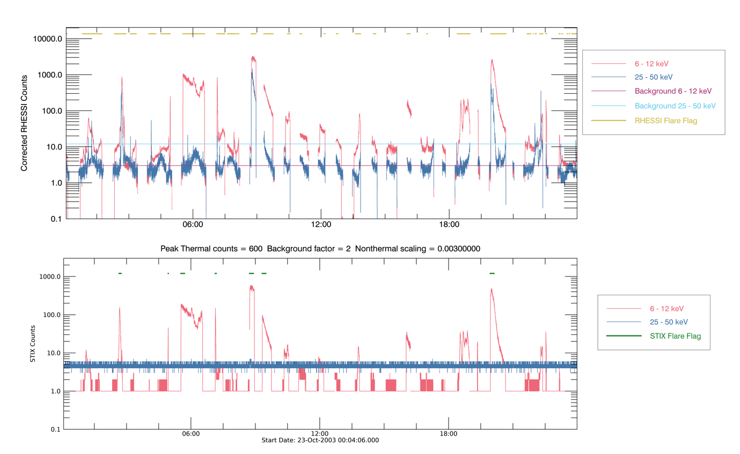

Figure 18: As Figure 10 with the non-thermal contribution reduced by a factor of 10, i.e. a thermal/non-thermal ratio of 0.003.

### Increased background estimates

As the true STIX background rate and spectra are unknown the profiles were generated with a range of increased constant backgrounds. Factors of 2, 4, 8 and 16 were applied to both the thermal and nonthermal backgrounds. It was found that due to the baseline estimation and the background estimate subtraction increasing the backgrounds in either energy band by a constant value had little effect on the reliability of flare detection.

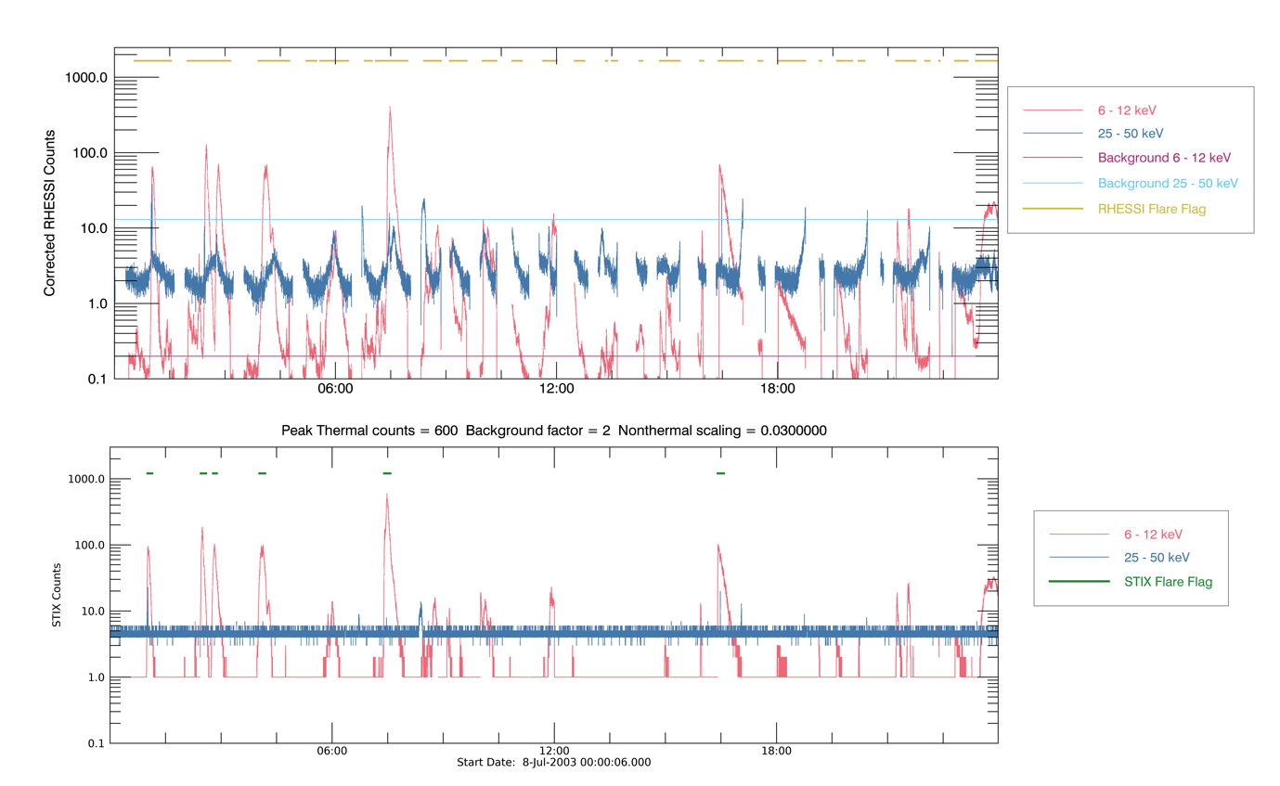

Figure 19 : Lightcurve for 8-Jul-2003 00:00 to 23:59. Top: Corrected RHESSI Counts in the standard energy bands 6-12 (red) and 25-50 keV (blue) along with the constant background estimates for each energy band (purple and light blue respectively. The RHESSI flare flag (yellow) for these counts is shown. Bottom: Estimate of STIX counts from hsi_extrct_flx photons in the flare detection thermal (red) and non-thermal (blue) energy bands. The STIX flare flag for these counts is shown (green). Here the background is enhanced by a factor of 2 above the nominal value.

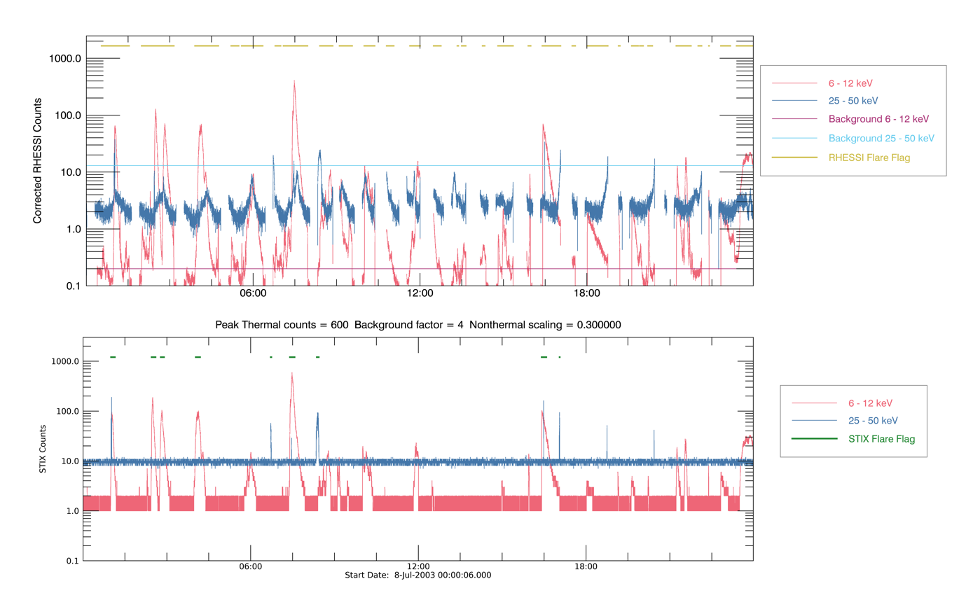

Figure 20 : As Figure 19 but here the background is enhanced by a factor of 4 above the nominal value.

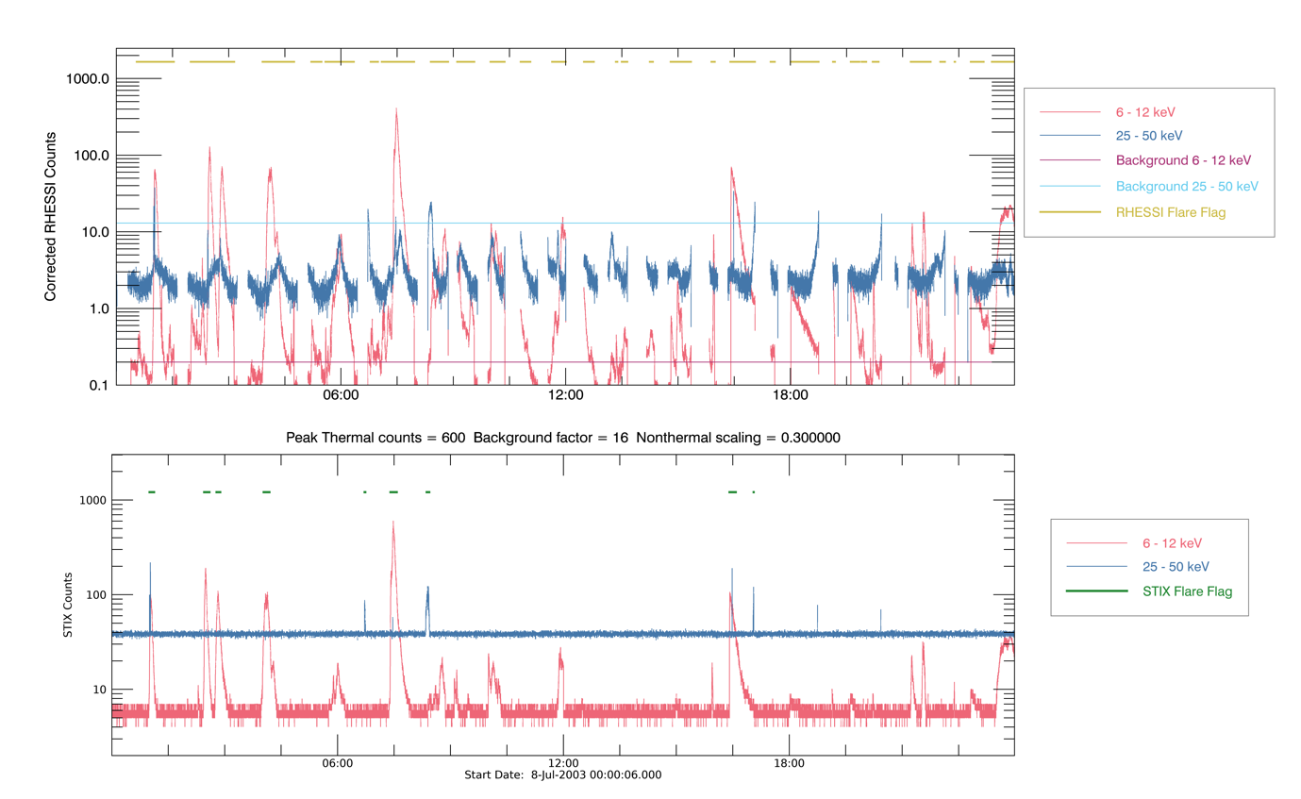

Figure 21: As Figure 19 but here the background is enhanced by a factor of 16 above the nominal value.

### Variable Background

To investigate the effect of a variable background a sinusoidally varying component is added to the background. The amplitude of this background component was then increased until the flare detection was triggered once every period. Initially a period of 90 minutes was tested. It was not until background was enhanced by a factor of 4 above the nominal values that the flare detection was reliably triggered. A period of 20 minutes (the length of the long time baseline in our standard configuration), here the flare flag was triggered at every peak with a background enhancement factor of 2.

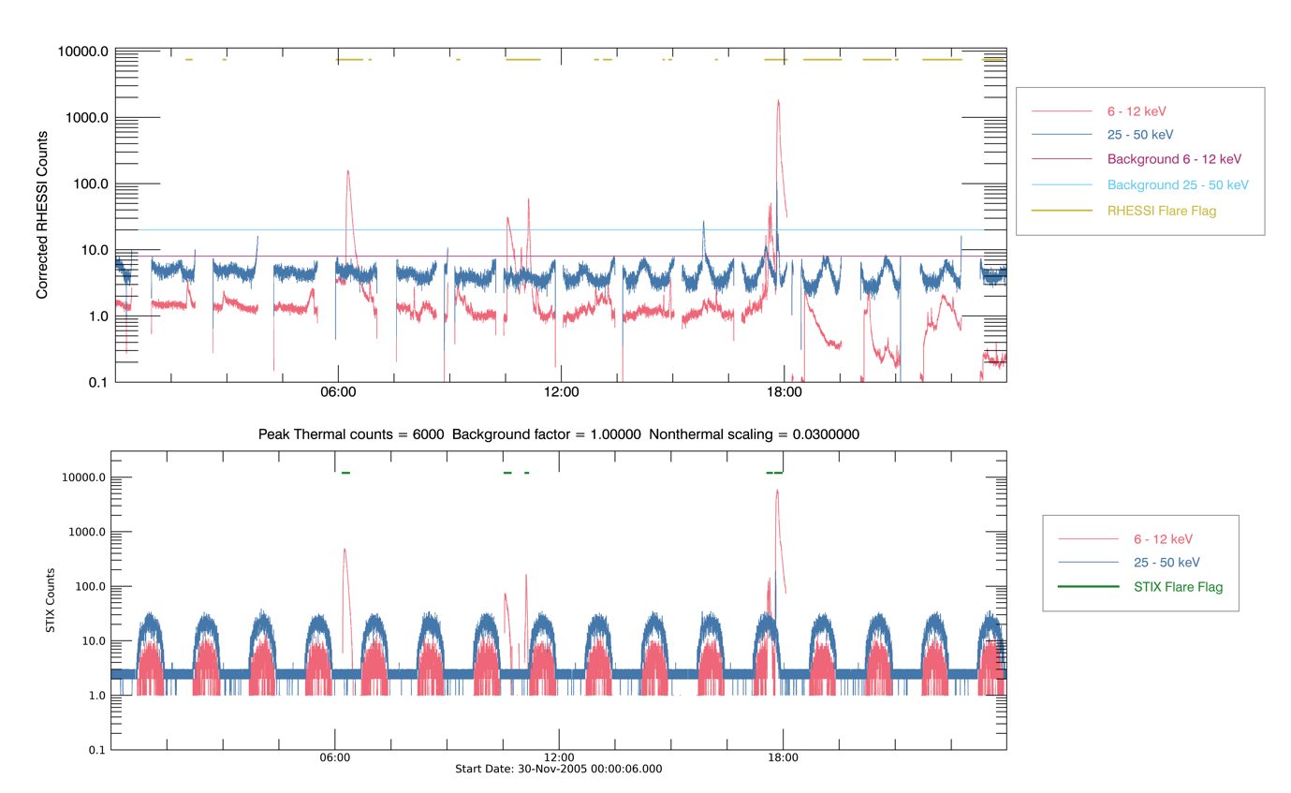

Figure 22: As Figure 9 with sinusoidal background component added. The parameters used for this component are Amplitude_thermal = 5 counts/4s, Amplitude_nonthermal = 20 counts/4s, period = 90 minutes.

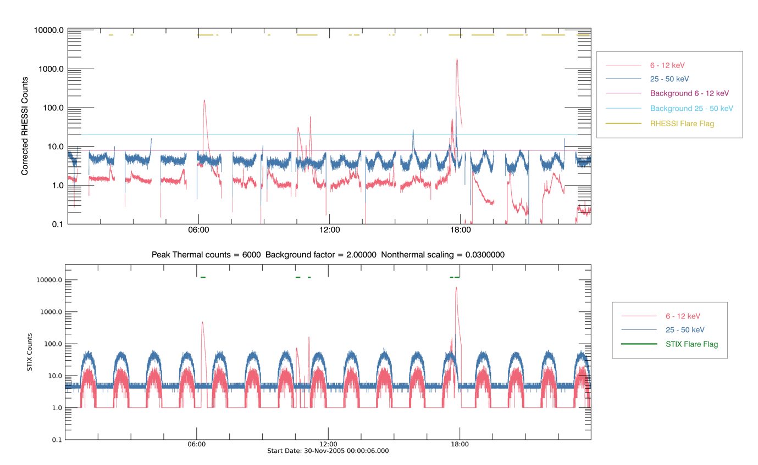

Figure 23 : As Figure 9 with sinusoidal background component added. The parameters used for this component are Amplitude_thermal = 10 counts/4s, Amplitude_nonthermal = 40 counts/4s, period = 90 minutes.

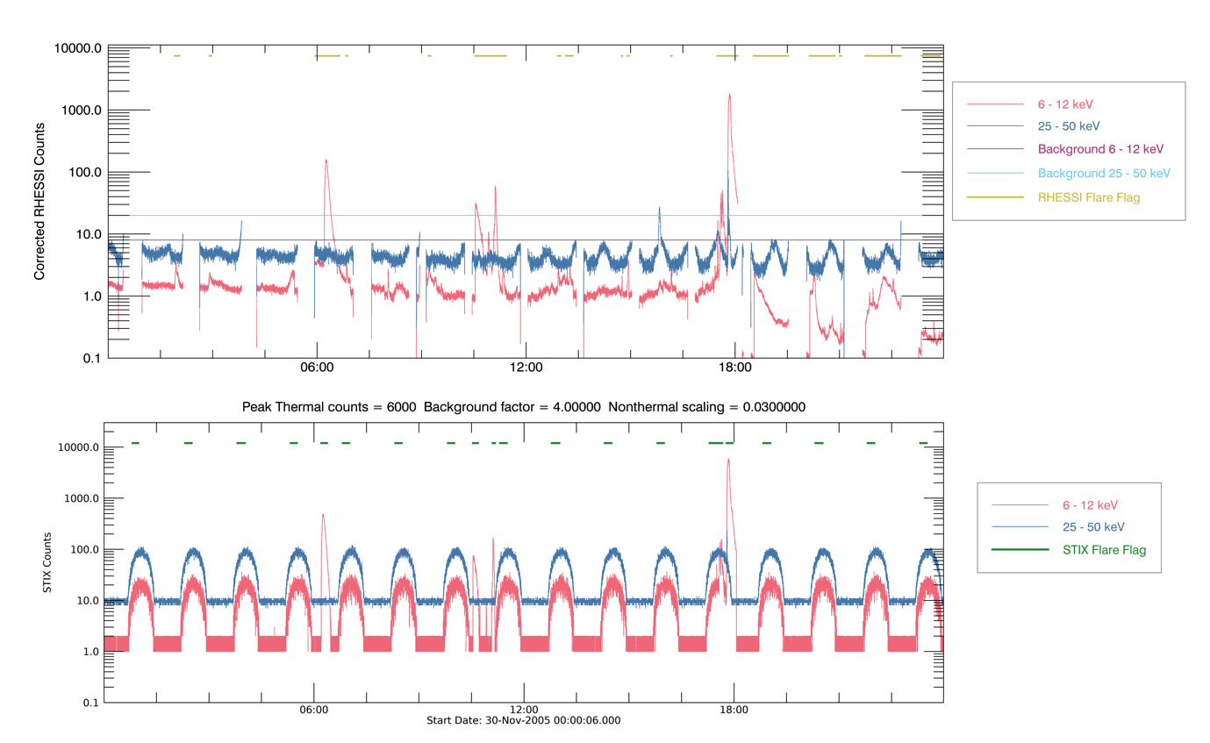

Figure 24 : As Figure 9 with sinusoidal background component added. The parameters used for this component are Amplitude_thermal = 20 counts/4s, Amplitude_nonthermal = 80 counts/4s, period = 90 minutes.

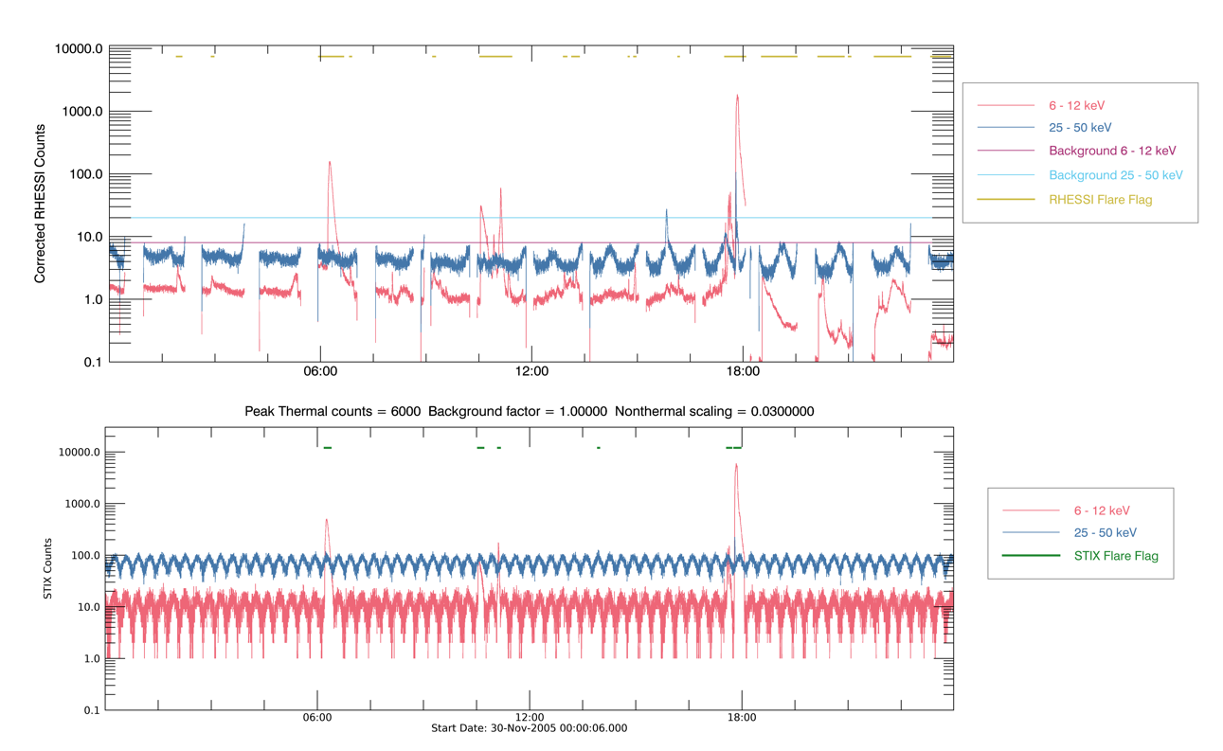

Figure 25 : As Figure 9 with sinusoidal background component added. The parameters used for this component are Amplitude_thermal = 5 counts/4s, Amplitude_nonthermal = 20 counts/4s, period = 20 minutes.

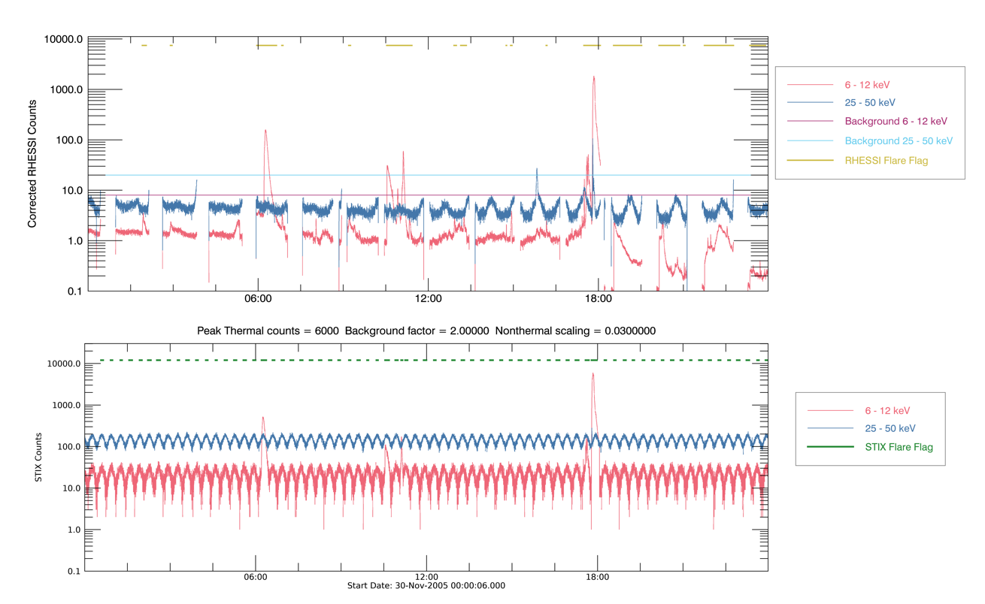

Figure 26 : As Figure 9 with sinusoidal background component added. The parameters used for this component are Amplitude_thermal = 10 counts/4s, Amplitude_nonthermal = 40 counts/4s, period = 90 minutes.